CUSTOMER LIFETIME VALUE ANALYSIS (CLTV)

What is CLTV?

Customer lifetime value (CLV or LTV) is **a metric used prediction of the total revenue a business can expect from a customer over their entire relationship with the company. This metric helps businesses understand the long-term value of a customer and can influence decisions related to marketing budget, resources, and profitability.**

**PROJECT DETAILS**

By analyzing customer lifetime value, companies can identify the most effective marketing channels and campaigns for acquiring high-value customers, as well as develop targeted retention strategies to keep those customers engaged and loyal.

DataSet used: <https://docs.google.com/spreadsheets/d/1W_EnprNqJW4pwo0rLR1gdTNg3rL9dhkQmGK1BYoj0fY/edit?usp=sharing>

Sample of dataset:



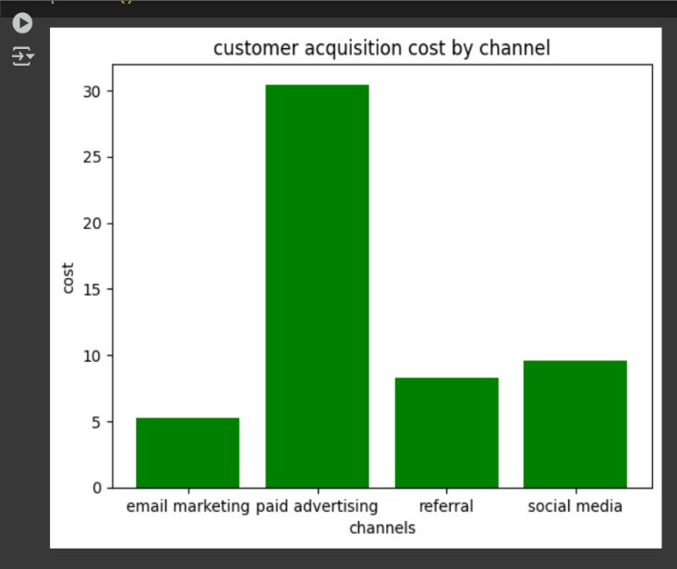**Customer Acquisition Cost (CAC) by Channel:**  
This chart provides an overview of how different marketing channels contribute to the overall customer lifetime value. It is evident that social media and referral channels outperform others in terms of CLTV, suggesting that these channels attract customers who make higher-value purchases over time. On the other hand, email marketing and paid advertising lag behind, with comparatively lower CLTV figures. This insight can help businesses prioritize and allocate resources to channels that provide long-term value.

**Conversion Rate and Total Revenue by Channels:**  
The bar chart shows the conversion rate achieved by each channel. Social media has the highest conversion rate, followed by referral. Email marketing and paid advertising have lower conversion rate. The donut chart shows revenue distribution by channel: Email Marketing (27.3%), Referral (25.7%), Paid Advertising (24.8%), and Social Media (22.2%). Email marketing generates the highest revenue, while social media contributes the least.

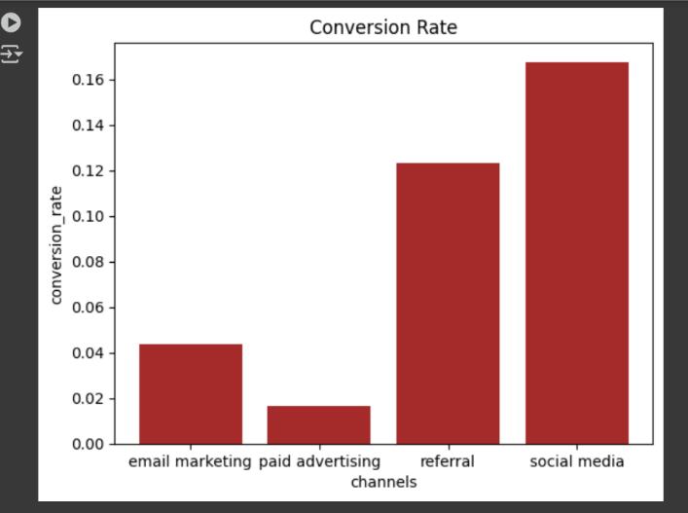 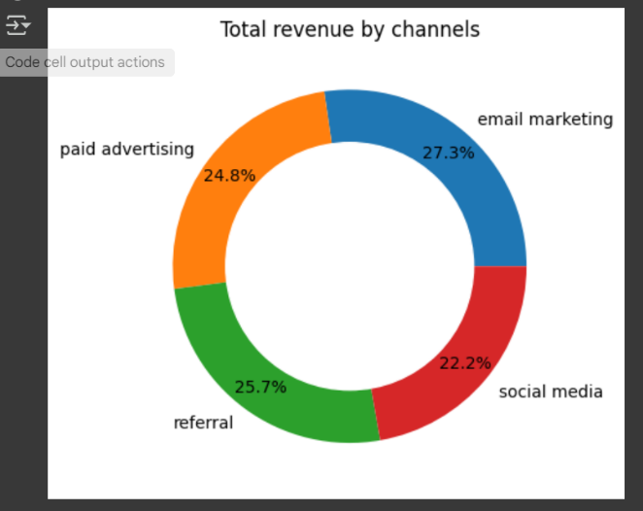

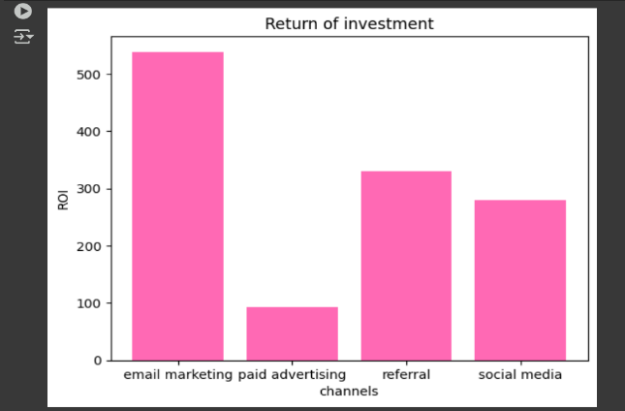**Return on Investment (ROI)**:  
The ROI chart measures the profitability of different marketing channels in relation to the money invested. Email marketing emerges as the most profitable channel, delivering the highest ROI due to its low-cost nature and ability to target specific customer segments effectively

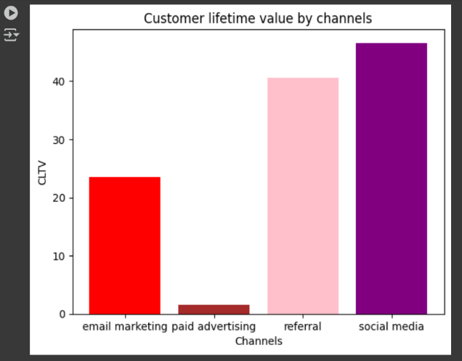**Customer Lifetime Value (CLTV) by Channels**:  
This chart provides an overview of how different marketing channels contribute to the overall customer lifetime value. It is evident that social media and referral channels outperform others in terms of CLTV, suggesting that these channels attract customers who make higher-value purchases over time. On the other hand, email marketing and paid advertising lag behind, with comparatively lower CLTV figures. This insight can help businesses prioritize and allocate resources to channels that provide long-term value.